# Space bar example

# Define P-value

p-value is the probability of NULL hypothesis to be true.

H0 (NULL Hypothesis)  
H1 (Alternate Hypothesis)

# Court of law example

H0 🡪 The person is true

Statistical Testing (i.e gathering evidence)

H0 > H1 (evidences are H0 < H1 (evidences are against   
supportive to that person, that person, so NULL hypothesis is  
so NULL hypothesis is True) False)

Why H0 is considered that the person is True??  
***NULL hypothesis treats everybody same and equal always.***

Statistical testing 🡪 Z-test, T-test, ANOVA, Chi-Square.  
p-value 🡪 Significance value

# One tailed and two tailed test

## College example

In a college of 1000 students, the average IQ was 100. In that college some group of scientists wants to give some medications to the students because they feel that because of the medication the IQ may increase. So they gave the medication to the students.   
After a month they took a sample of 30 participants, average IQ was 140.

Do the average IQ of the population after medication has changed ??  
This question give raise to two-tail test.

H0 : u=100 and H1: u!=100

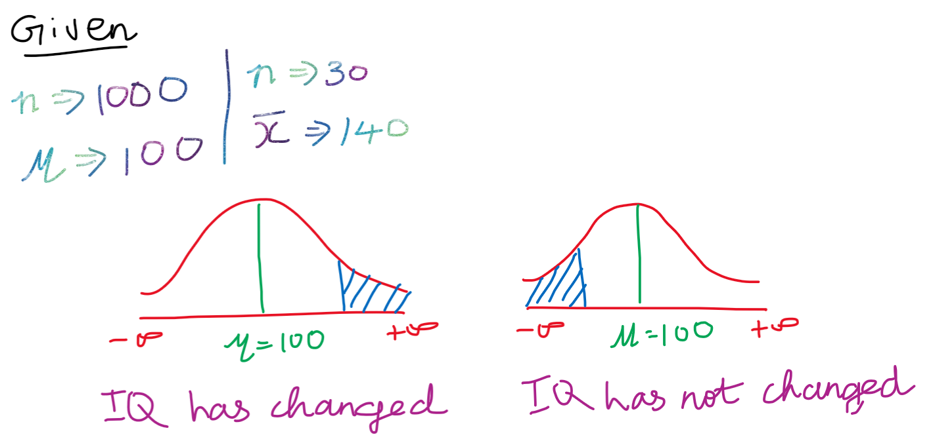

After the statistical testing the IQ can be increased/decreased. We cannot say definitely.

Whether the average IQ of the population after medication is greater than 120 (or) is less than 60???  
This question give raise to one tail test.  
Greater than 120 🡪 IQ is increased

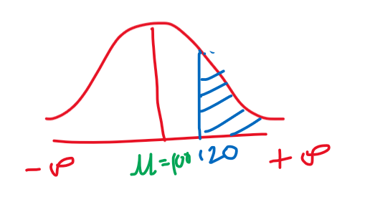  
Lesser than 60 🡪 IQ is decreased

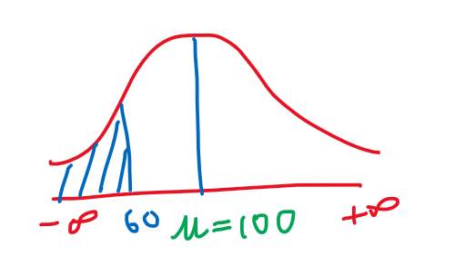

p-value for two tailed test

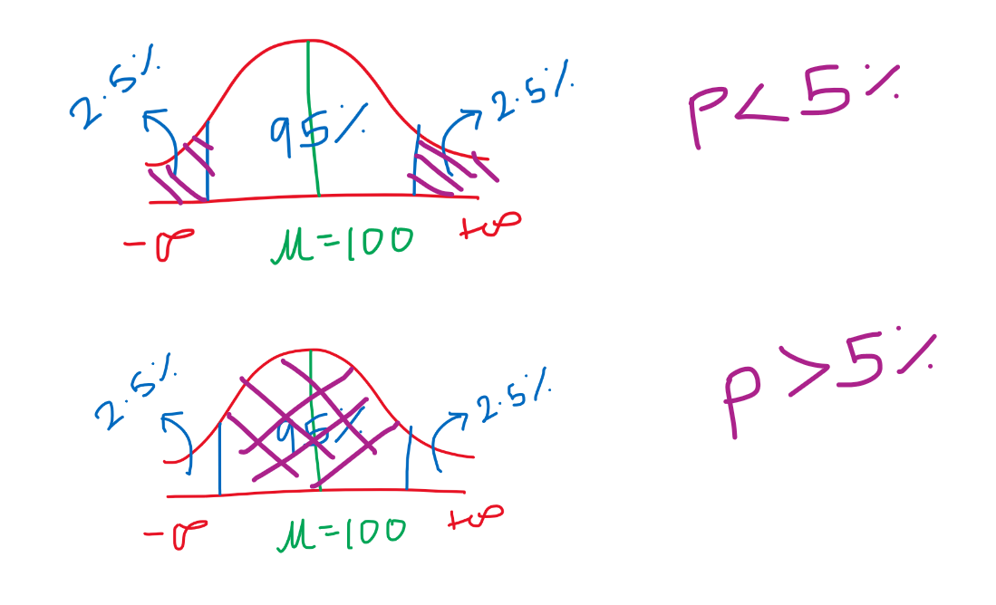

***Two tail test 🡪 Equal / not equal  
One tail test 🡪 Lesser than / greater than***

# Statistical and Practical significance

In statistical we are focussed more on values.  
In practical we are focussed more on direction (whether it is going towards that/not)

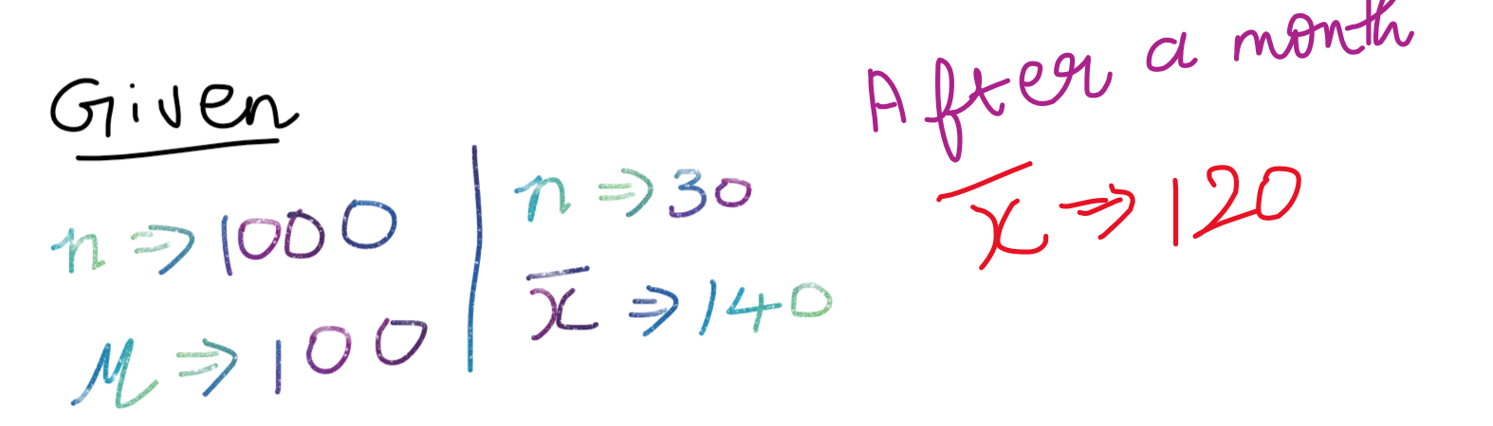

Even-though xbar has not reached 140, it has came somewhat so closer, but in statistical approach we cannot able to see the difference. In practical approach we can see the difference

# Independent sample and Dependent sample

All the machine learning problems we handle, we will use only the sample data and not the population data.  
dependent sample 🡪 Height and weight | experience and salary  
independent sample 🡪

# Z-test (compare mean , population sd is given)

Z-test and Z-score are completely different

# t-test (population sd is not given)